GOOSNARGH & LONGRIDGE AGRICULTURAL SOCIETY LIMITED
SPONSORSHIP FORM - 2026
We invite you either as an individual or a company to sponsor a part of the show. We need sponsorship to
enable us to carry on holding the show in its current format as costs are constantly increasing.
Types of Sponsorship Available
Platinum Package - £400
{Includes - 20 show entry wristbands, 8 Show day lunch tickets, access to hospitality area on show day}
Gold Package - £300
{Includes - 15 show entry wristbands, 6 Show day lunch tickets, access to hospitality area on show day}
Silver Package - £200
{Includes - 10 show entry wristbands, 4 Show day lunch tickets, access to hospitality on show day}
Bronze Package - £100
{Includes - 5 show entry wristbands, 2 Show day lunch tickets, access to hospitality area on show day}
Please see the attached sheets for the available sponsorship opportunities and the level of Sponsorship
required to be associated with each opportunity.
All the above sponsorship packages include your inclusion in a sponsors list on the show website and in our
annual brochure {5,000 copies printed and distributed over a large area}. Your company logo can be
Included, along with your name and address. Final deadline for the brochure is 27th April 2025.
On show day your name and logo {if required} will be on large sponsors list signs which are located in
prominent positions on the show field. Your name will be mentioned on the PA through the day to let the
public know who has sponsored the show. If you sponsor a section you will be able to present prizes to the
winners therefore giving a photo opportunity for publicity purposes.
For section sponsors we will have a sign outside each marquee stating who has sponsored that section
{logo can be included}. The sign will promote your company to the thousands of visitors as they circulate
around the show field.
Individual Area Sponsorship such as Mobility Scooters, PA System etc - Please see Page 2
Individual Class Sponsorship - Please see Page 2
Sponsor's Name:
Please state type of sponsorship required:
Address:
email address:
Tel/Mobile number:
Amount Enclosed:
Cheques to be made payable to - GLAS
Is a receipted invoice required - please state: YES or NO
Signature:
Date:
Page 1 of 2
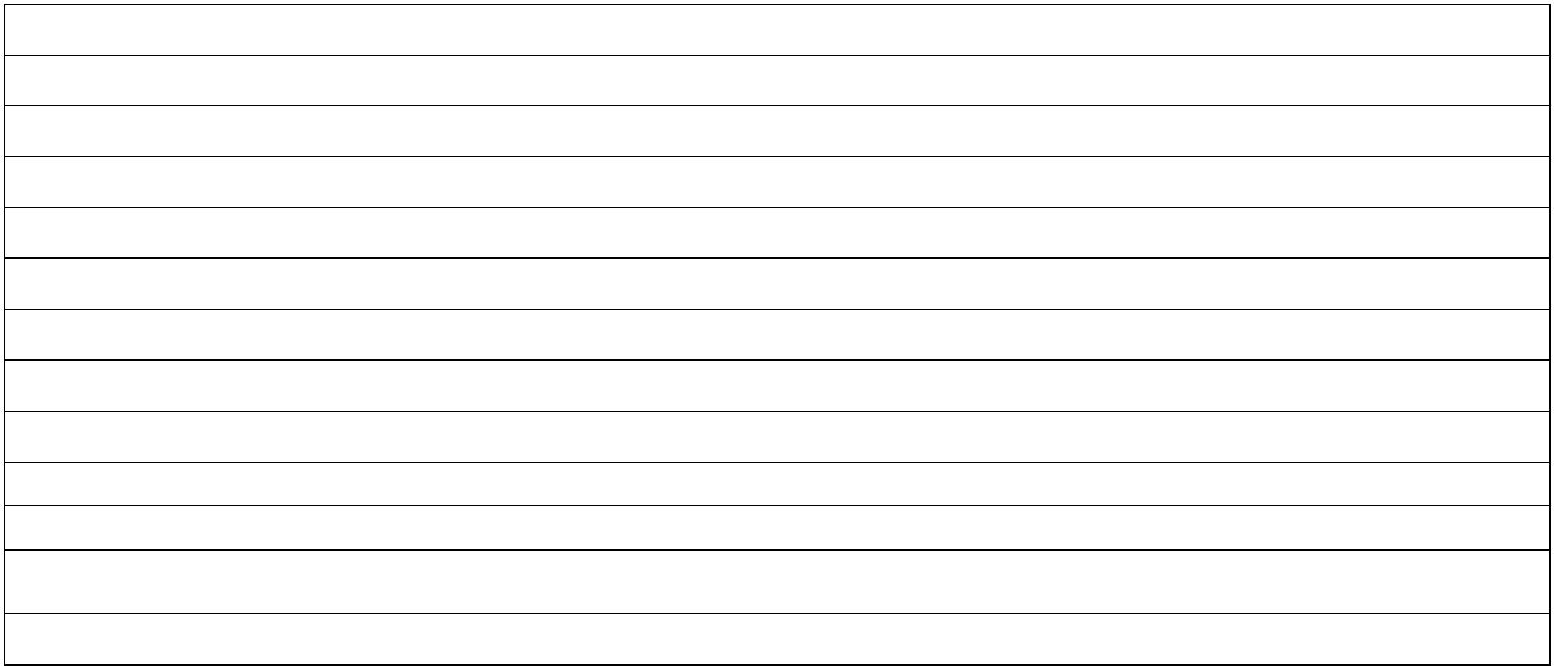

GOOSNARGH & LONGRIDGE AGRICULTURAL SOCIETY LIMITED
SPONSORSHIP FORM - 2026
Show Day Sections for sponsorship and the level of sponsorship required to be associated with the section.
Pet Dogs
Bronze Sponsorship
Bronze Sponsorship
Bronze Sponsorship
Silver Sponsorship
Silver Sponsorship
Silver Sponsorship
Silver Sponsorship
Silver Sponsorship
Silver Sponsorship
Silver Sponsorship
Gold Sponsorship
Gold Sponsorship
Gold Sponsorship
Gold Sponsorship
Platinum Sponsorship
Platinum Sponsorship
Web Site
WI
Food & Craft
Horticulture
Poultry
Sheep
Trade Stands
Vintage Vehicles
Young Farmers Club
Community Marquee
Light Horse
Pedigree Dogs
Junior Section
Cattle
Heavy Horse
Other sponsorships available see below:
Childrens Entertainment Area:
Climbing Wall, Merry Go Round, Face Painting, Circus Skills,
Bouncy Slide, Donkey Rides etc
Each attraction requires a silver sponsorship
First Aid Facilities & Paramedics
Annual Wristbands for Show Entry
Band Entertainment {such as Ukele Band etc}
Mobility Scooters
Gold Sponsorship
Gold Sponsorship
Silver Sponsorship
Silver Sponsorship
Silver Sponsorship
Silver Sponsorship
PA System
Waste Disposal & Skips
Individual Classes in any section can be sponsored as follows
Heavy Horse Section - £25
Cattle Section - £25
Light Horse Section - £20
Sheep Section - £15
Pedigree Dogs - £10
All other classes - £5
Please send these forms and payment to:
Mr. Graham Kelsall {Treasurer}
The Old Vicarage
Lower Lane
Longridge
PR3 3SL
email: graham@oaktreehouse.net
Page 2 of 2
